**BLESSINGS BOUTIQUE -Dress Sale Instructions/Guidelines**

Please follow these specific guidelines:

* MODEST WOMEN’S AND GIRL’S DRESSES & SKIRTS ONLY (All other clothing or items will be removed from the sale)
* **The only non-clothing items you may bring to the sale are PURSES!**
* **Items need to be cleaned, tagged, and already on hangers when you arrive Friday.** Skirt hangers are ideal and recommended for skirts. Purses are the only items that will not be on a hanger.
* Hanger hooks need to be to the LEFT when the article of clothing is facing you. (We will not be returning your hangers to you).
* Tags need to be on the RIGHT, pinned to the clothing, (not the hanger) when the article of clothing is facing you.
* Purses will not be on hangers but do need a tag. Please loop the tag around the strap of the purse using the string on the tag to secure it, or you may use a safety pin if you choose.
* Dresses/skirts and purses may be donated (proceeds will go to the Ladies Retreat fund), or you will be assigned a number and receive the proceeds when you pick up any unsold dresses/skirts and purses.
* All unsold items must be picked up immediately after the retreat or they will be donated to a local charity.
* **No straight pins**: Please use **safety pins** to tag your clothing.
* Make sure your tags are secured and clearly visible. If your tags fall off, we have no way of knowing whose number the clothes are assigned to.
* Any article without a tag will be priced accordingly and the proceeds will go to the Ladies Retreat fund.
* Use whole dollar amounts when pricing your items; tags will be rounded to a whole dollar amount.
* **Cash only; no checks or credit cards**. Please bring small bills for shopping!
* Please remember the suggested pricing for dresses/skirts and purses is $5.00 or less; our goal is to be a blessing to others- hence the name, Blessings Boutique!
* **All items to be sold must be checked in at the retreat on Friday between 3:00-4:45pm ONLY!**
* Roswell Baptist Church is NOT responsible for any lost, stolen, or missing articles of clothing or purses.
* If you are bringing items to the sale, **YOU MUST GET A SALE NUMBER ASSIGNED TO YOU by texting Autumn Fuentes 575-973-3742.** This will allow you to tag and number items **BEFORE** you arrive on Friday. You may also call if you have further questions.
* Tags may be purchased at Wal-Mart, Dollar Tree, Amazon or office supply stores, (check the home office aisles).

**TAG INSTUCTIONS:** Place garment **Size & Price** on one side of tag & your **Assigned Number** on the other side.

Assigned #

Price

Size

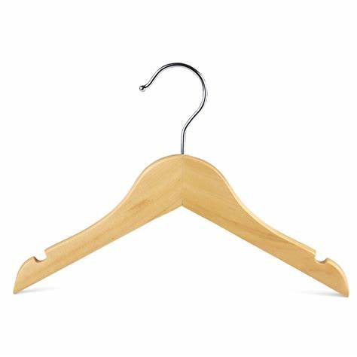

Hooked to Left

Tag to the Right, pinned to the clothing, not the hanger.